|  |  |
| --- | --- |
| **WC Logo.emf** | **Staff Report to the Weber County Commission**  *Weber County Planning Division* |
|  | |

****Synopsis****

****Application** Information**

**Application Request: P**ublic hearing to discuss and take action on a proposal to amend the zoning code for the CV-1 and CV-2 Zone of the Ogden Valley to reduce the front yard setback, include complete street design, and add sections for building maintenance contract and cross access easement.

**Agenda Date: Tuesday, August 04, 2020**

**Applicant:** Weber County Planning Division

**File Number:** ZTA 2020-02  
**Frontier Address:** <https://frontier.co.weber.ut.us/p/Project/Index/10567>

****Staff Information****

**Report Presenter:** Felix Lleverino

flleverino@co.weber.ut.us

(801) 399-8767

**Report Reviewer: CE**

Applicable Ordinances

Chapter 104-21: Commercial Valley (CV-1, CV-2)

Summary and Background

This staff-driven text amendment has become necessary to shape the design of the street frontage improvements and the design of the commercial buildings in the Ogden Valley. It applies architectural standards and complete street standards for building facades that front on a street in the village areas, as directed by the Ogden Valley General Plan. During a development proposal meeting with an Ogden Valley resident and after reviewing the proposal against the CV-1 and CV-2 Zone Code, it became clear that text amendments to the CV zones are necessary in order to facilitate pedestrian-friendly storefronts and provide sufficient area to the rear of the buildings for parking, thru-access, pedestrian access, and visitor outdoor gathering areas. In keeping with aesthetically desirable areas available for visitors, it has also become evident that there are non-pedestrian friendly commercial structures that should be set-back from the main thoroughfare, for example, car wash operations. This amendment is intended to be a temporary fix until the village zone, currently under development by staff, can be properly vetted by the Planning Commission and then forwarded to the County Commission for possible implementation. This amendment only applies to commercial zones.

Summary of Proposed Amendments

**CV-1, CV-2 Text Amendments**

Clerical Edits:

The re-numbering of the sections and the redesign of the site development table are being made so that they conform to standard practices and make the table easier to use.

Edits to add definitions for terms added to the zoning code:

These definitions have been created to clarify the meanings of various terms and to be helpful in determining applicability.

Edits to the minimum front-yard setback requirement (Sec. 104-21-2):

This allows for the commercial building to be close to the sidewalk.

Edits to carwash operations to be setback at least 60 from the front property line (Sec 104-21-4(b)(3)):

For the purposes of this section, a minimum of 30-feet of the property frontage is to be reserved for commercial buildings and related improvements.

Edits to complete street design applicability (Sec 104-21-4(c)(1),(2)):

The village core areas of Ogden Valley will benefit by having uniformity of right-way-improvements like 10’ wide sidewalks, pedestrian lighting, landscaped areas, shade trees, and street crossings.

Edits to add provisions for a Perpetual Building Maintenance Contract (Sec 108-21-4(e)):

Commercial buildings that are built at a zero set-back from the side property line will coordinate with the neighboring landowner to allow for construction and maintenance.

Edits to add provisions for a Cross Access Easement (Sec 108-21-4(f)):

With building set close to the sidewalk, vehicle parking and thru-access to the rear of the buildings will be shared by businesses.

Noticing Compliance

A hearing for this item was published in compliance with UCA §17-27a-205 and UCA §17-27a-502 in the following manners:

Posted on the County’s Official Website

Posted on the Utah Public Notice Website

Published in a local newspaper

Planning Commission Recommendation

This text amendment was discussed with the Ogden Valley Planning Commission on February 25, 2020, and April 7, 2020. Following a public hearing held on April 28th, 2020, the Ogden Valley Planning Commission forwarded a positive recommendation to the County Commission by the vote of Chair Lewis, Hogge, Howell, Francis, Burton, Wood, and Waldrip all in favor.

The final paragraph of the proposal was not contemplated by the Planning Commission. It came up as a concern after the Planning Commission review of the ordinance and is related to a current development application. It is intended to ensure that adjacent public parking areas connect to each other without the need to reenter the public street. This will reduce vehicle-to-vehicle conflict in public rights of way and will reduce vehicle-to-pedestrian conflict along the street frontages.

Staff Recommendation

Staff’s recommendation remains consistent with the recommendation given to the Ogden Valley Planning Commission in the April 28th staff report, and as forwarded below:

Staff recommends that the County Commission consider the text included as **Attachment A**. Should the County Commission be comfortable with the proposal, it could be approved based on the following findings:

1. The changes are supported by and are part of the execution of, the 2016 Ogden Valley General Plan.
2. The changes are necessary to clarify provisions in the Land Use Code.
3. The clarifications will provide for a more efficient administration of the Land Use Code.
4. The changes will enhance the general health and welfare of County residents.

Attachments

1. Proposed Ordinance
2. Planning Commission Staff Report
3. Ogden Valley Planning Commission Meeting Minutes (04/28/2020)

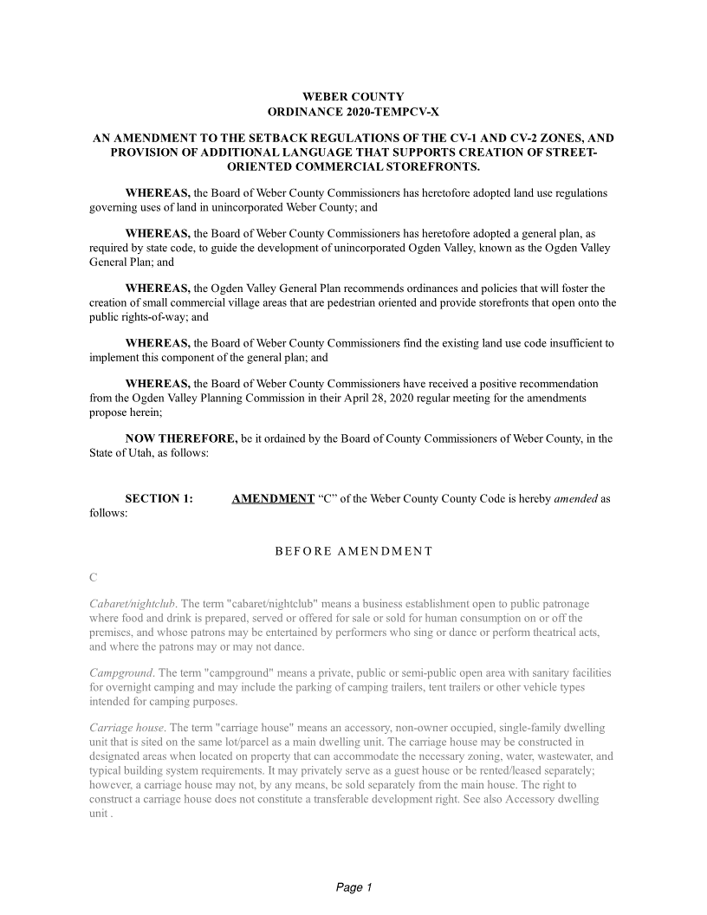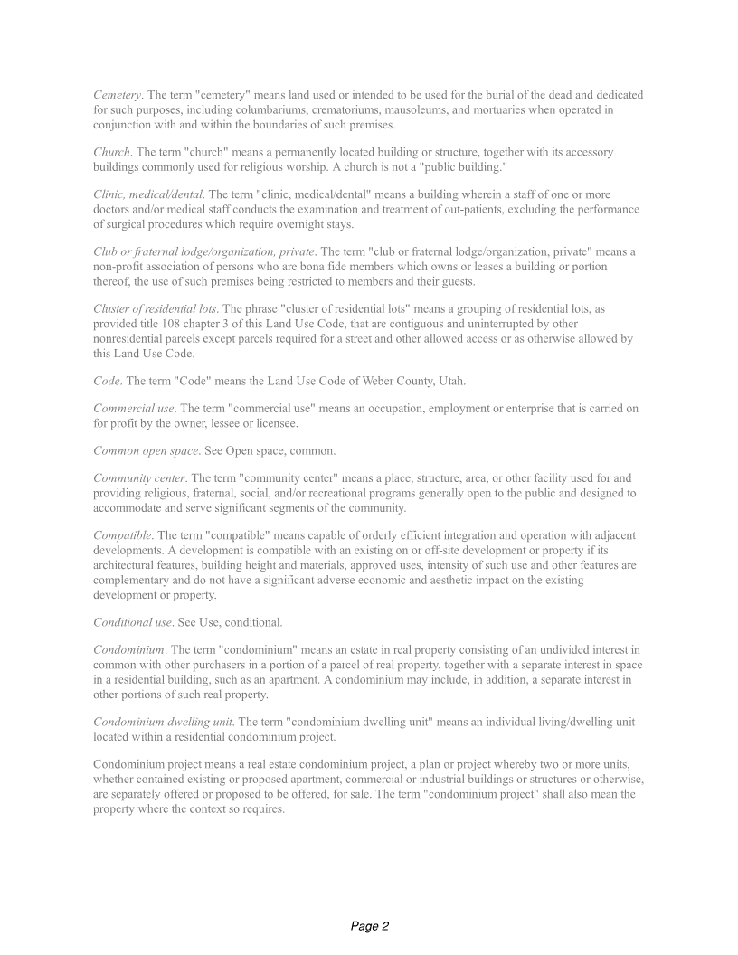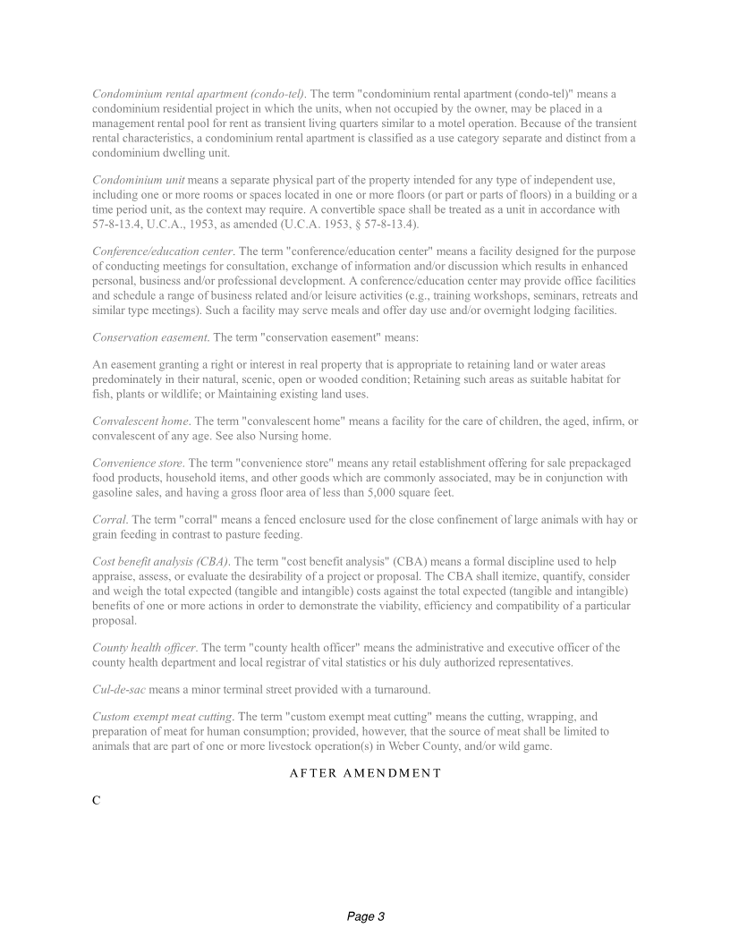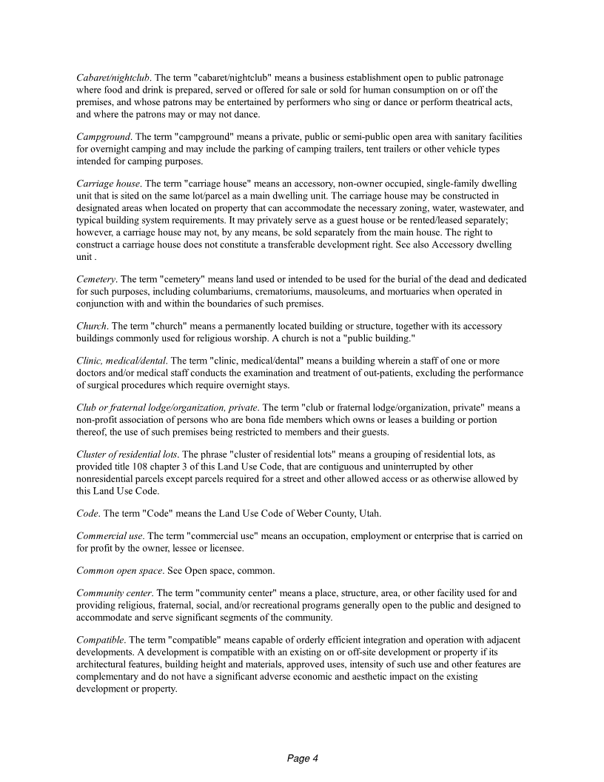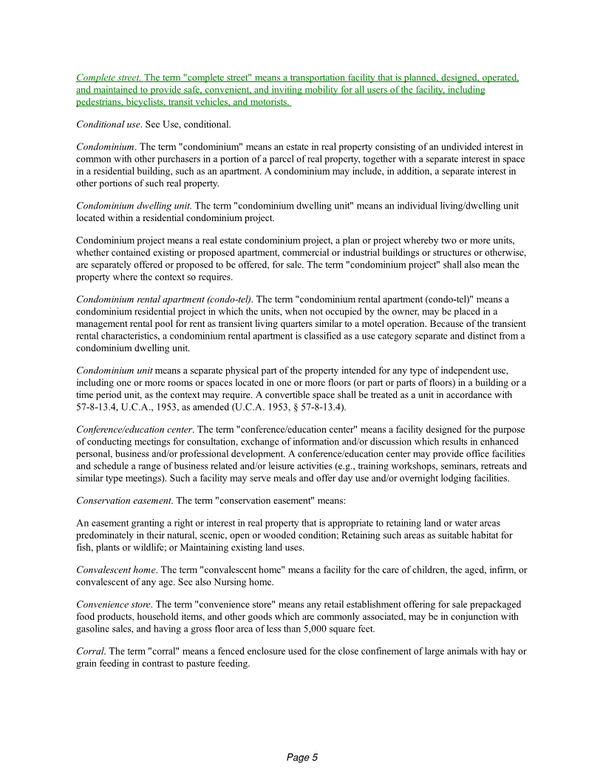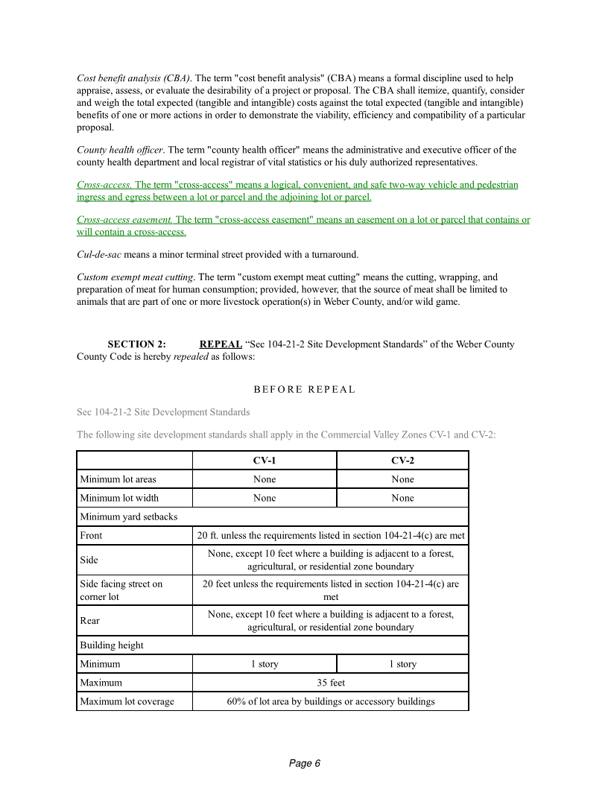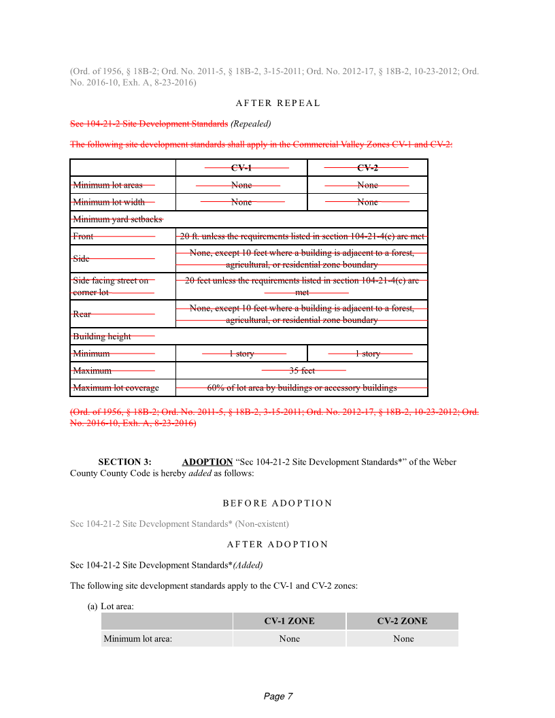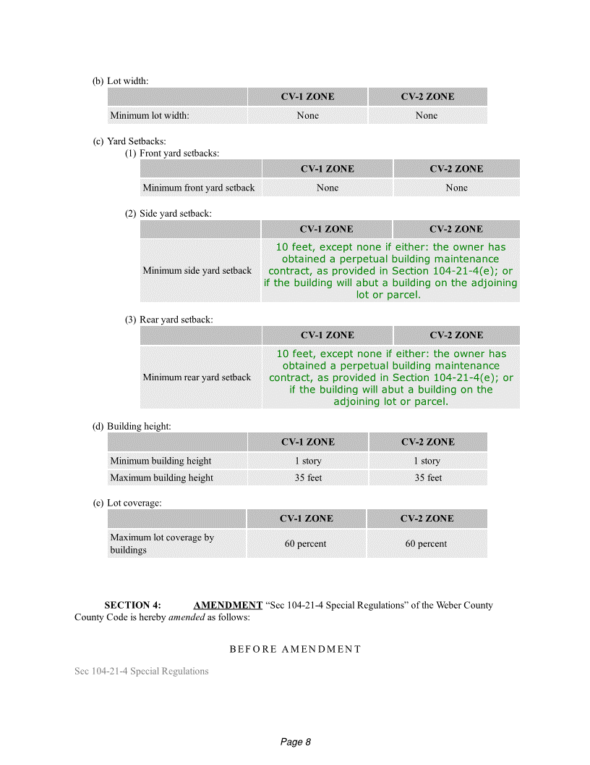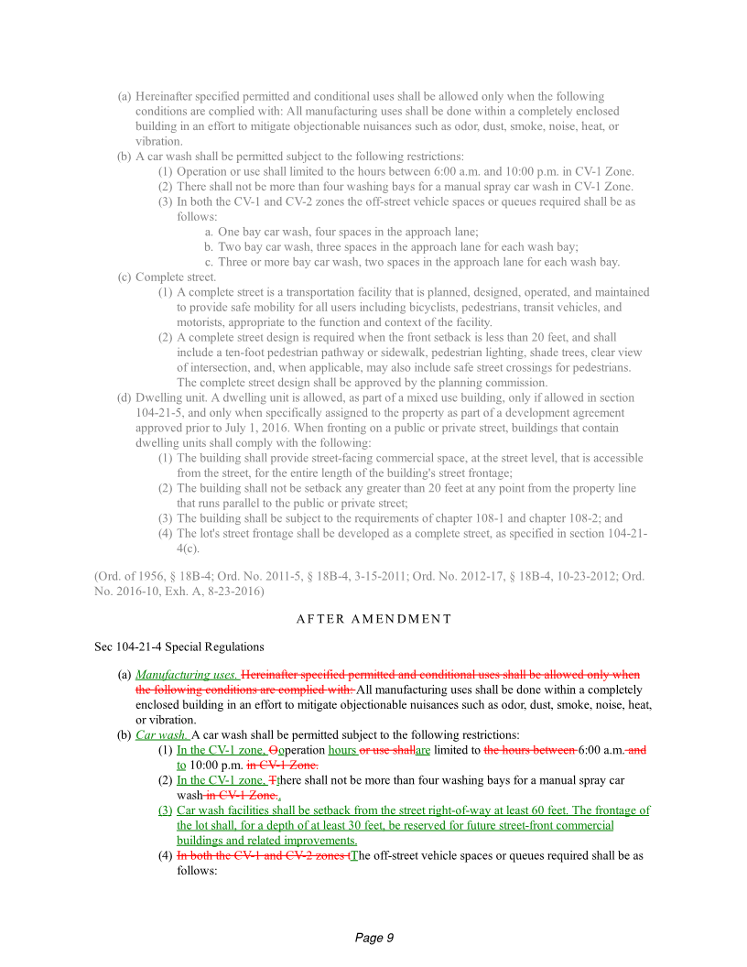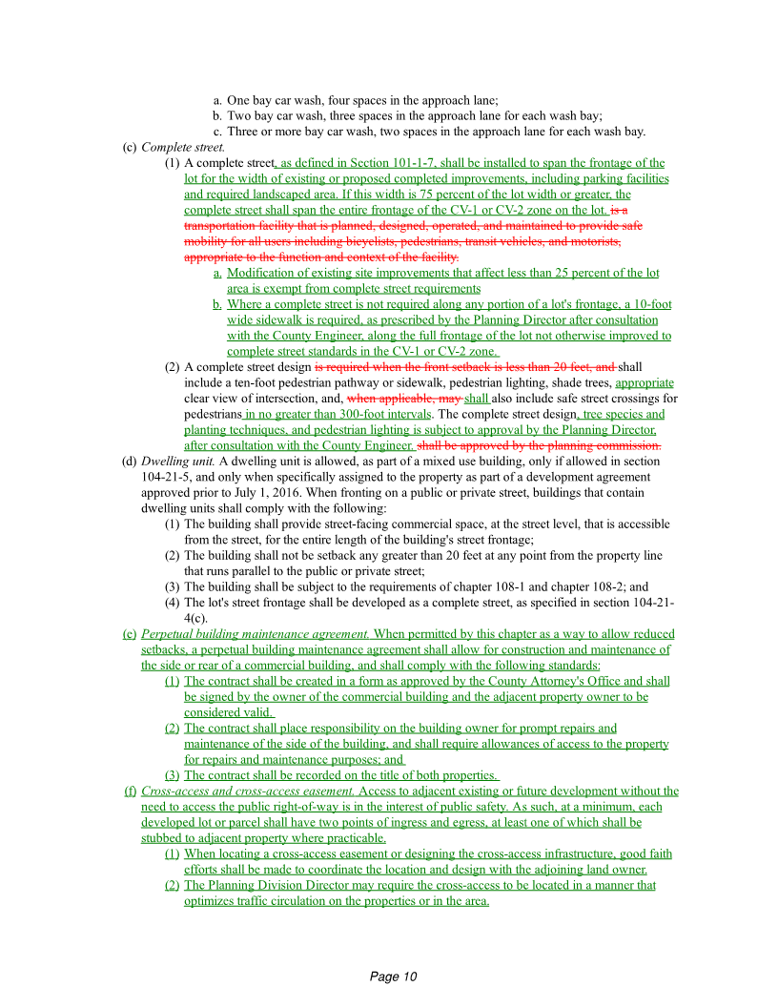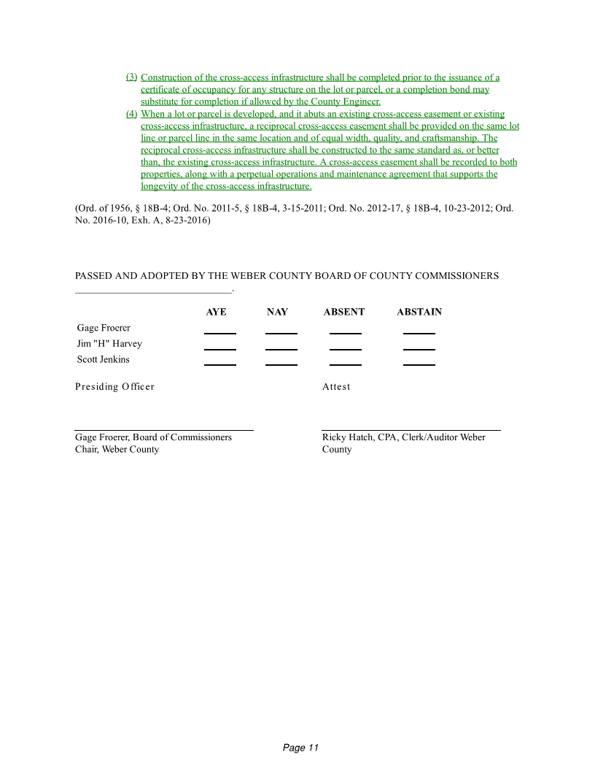

Ordinance: Attachment A

Ordinance: Attachment A

Ordinance: Attachment A

Ordinance: Attachment A

Ordinance: Attachment A

Ordinance: Attachment A

Ordinance: Attachment A

Ordinance: Attachment A

Ordinance: Attachment A

Ordinance: Attachment A

Ordinance: Attachment A

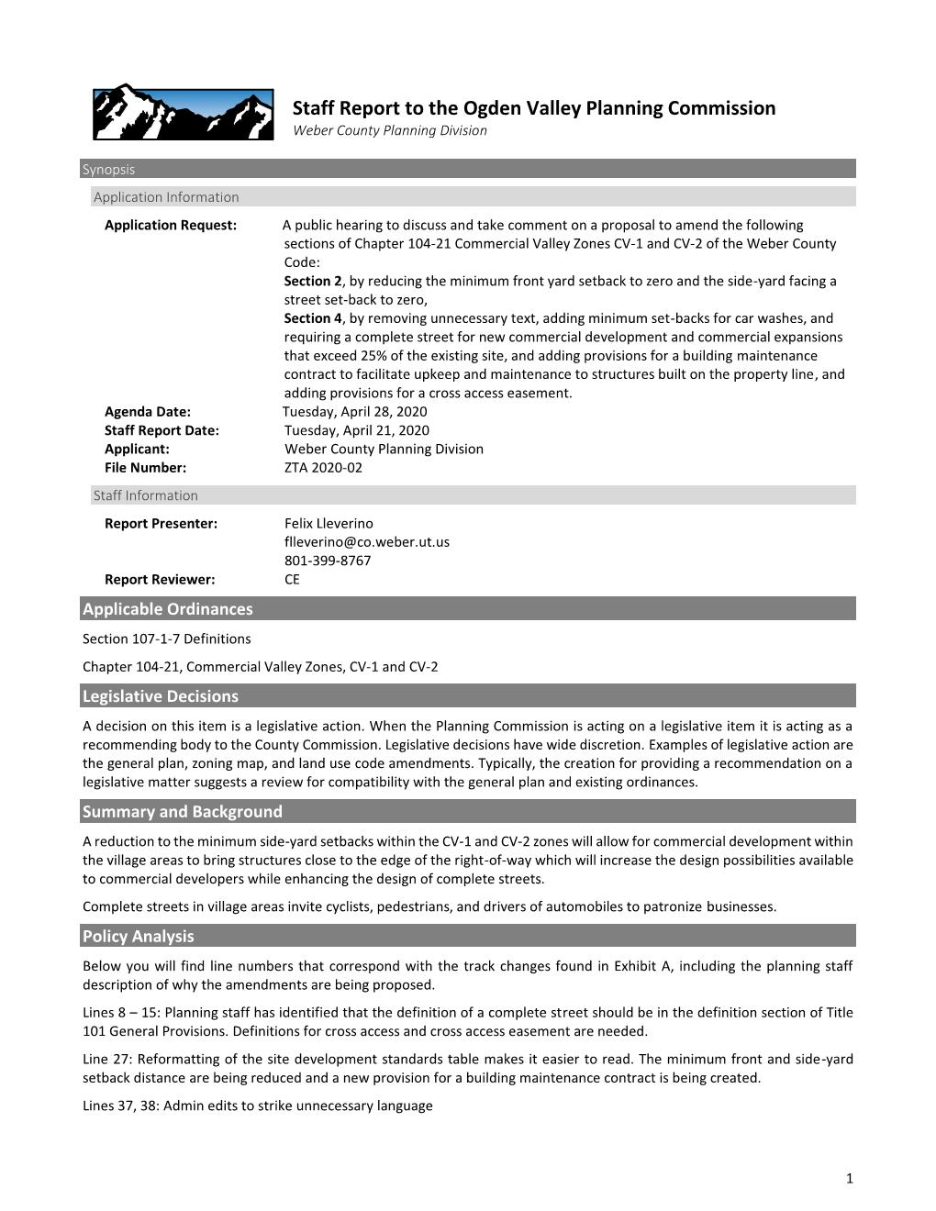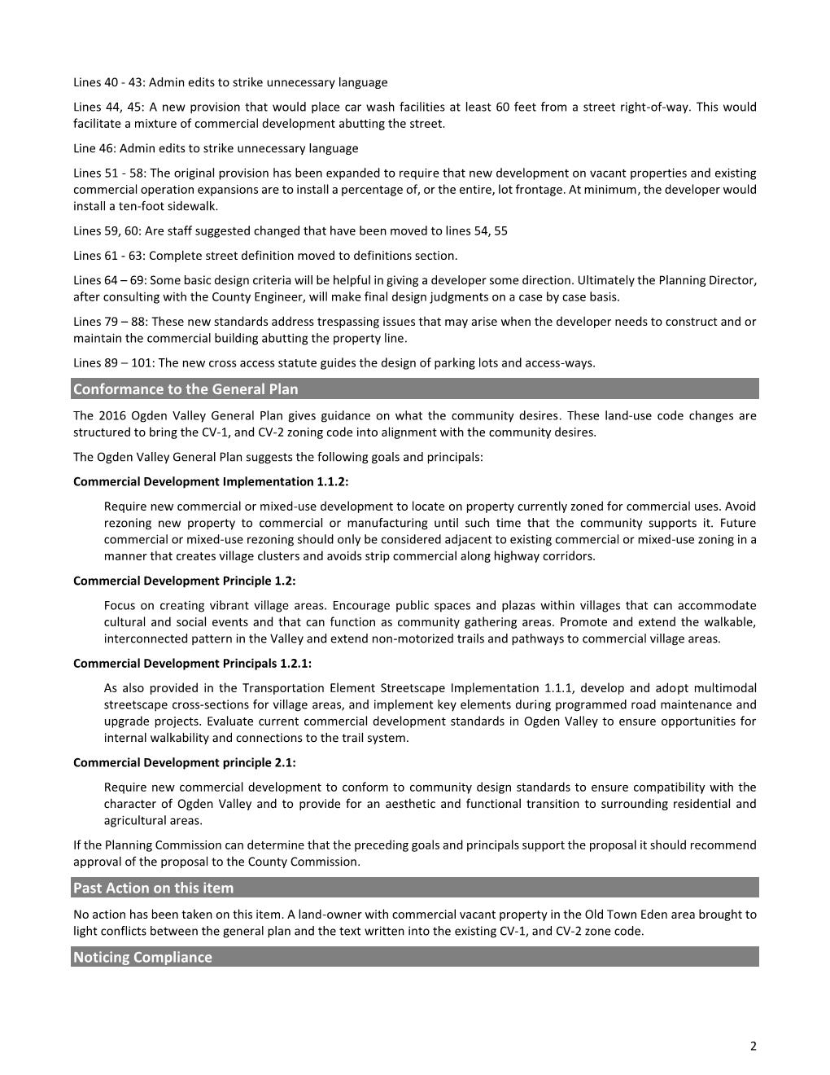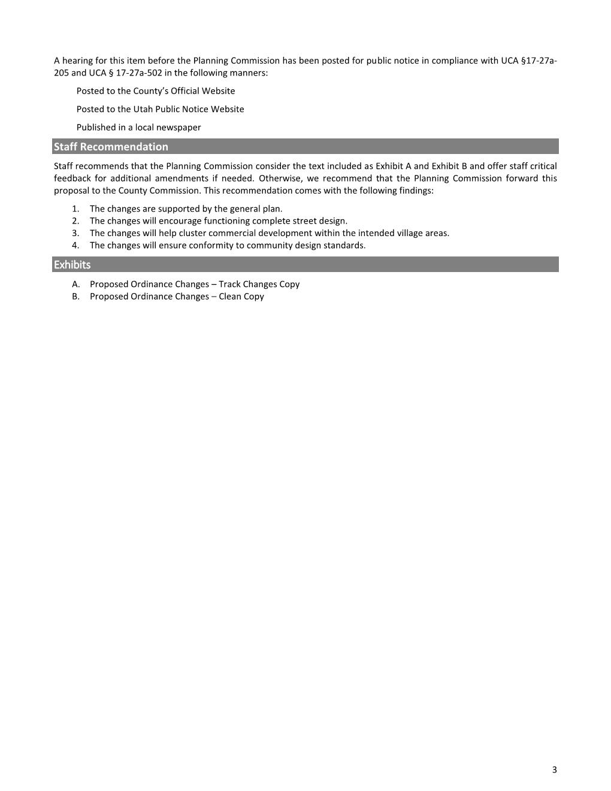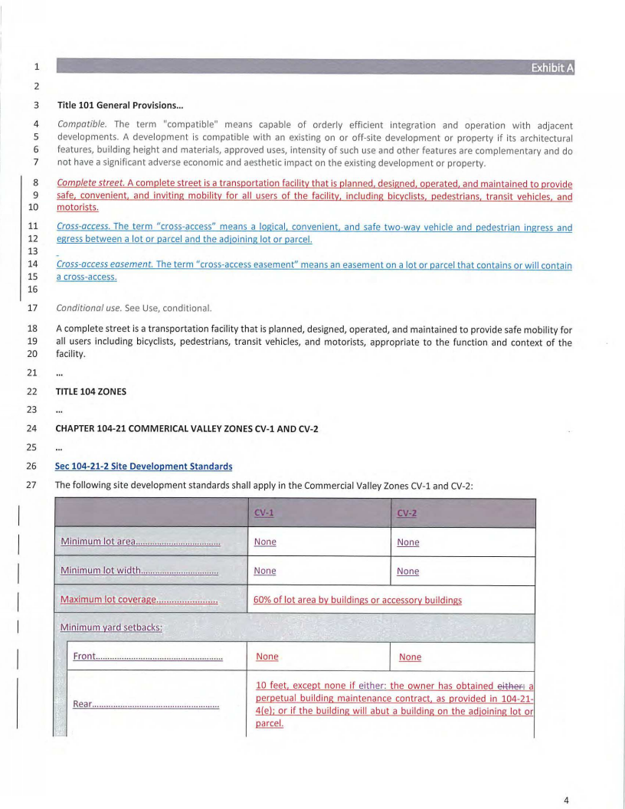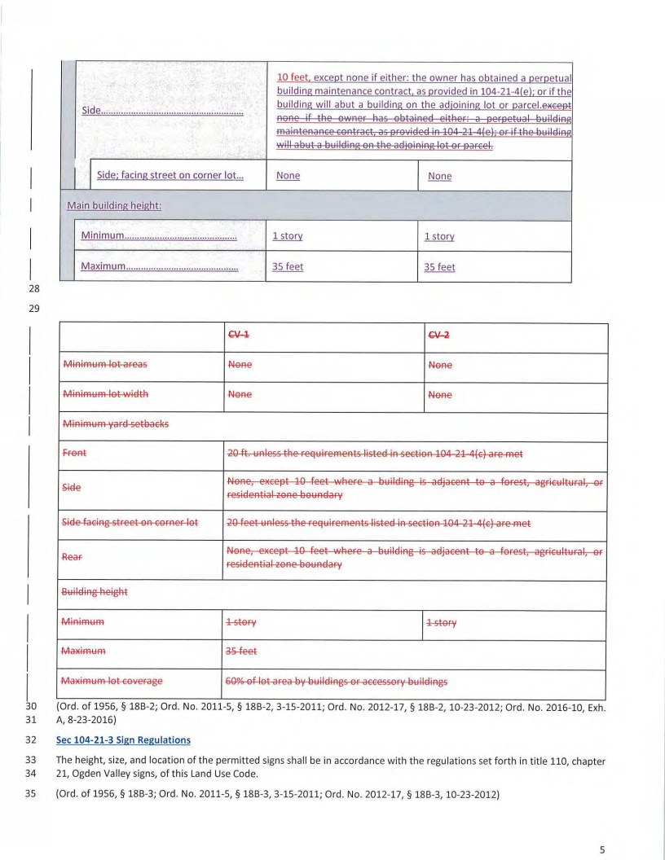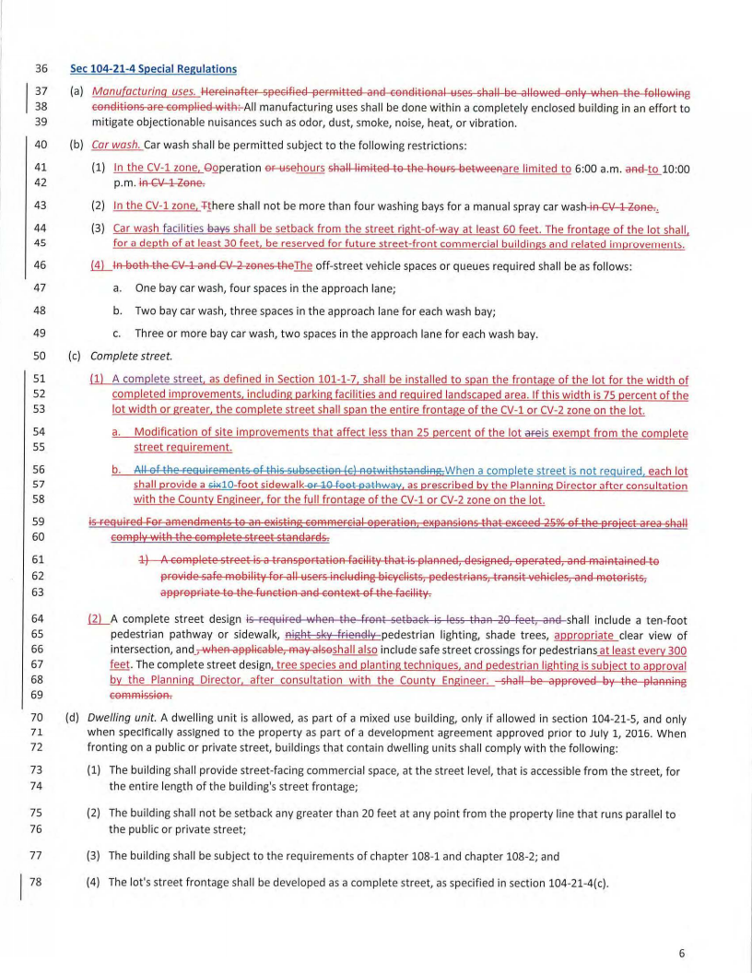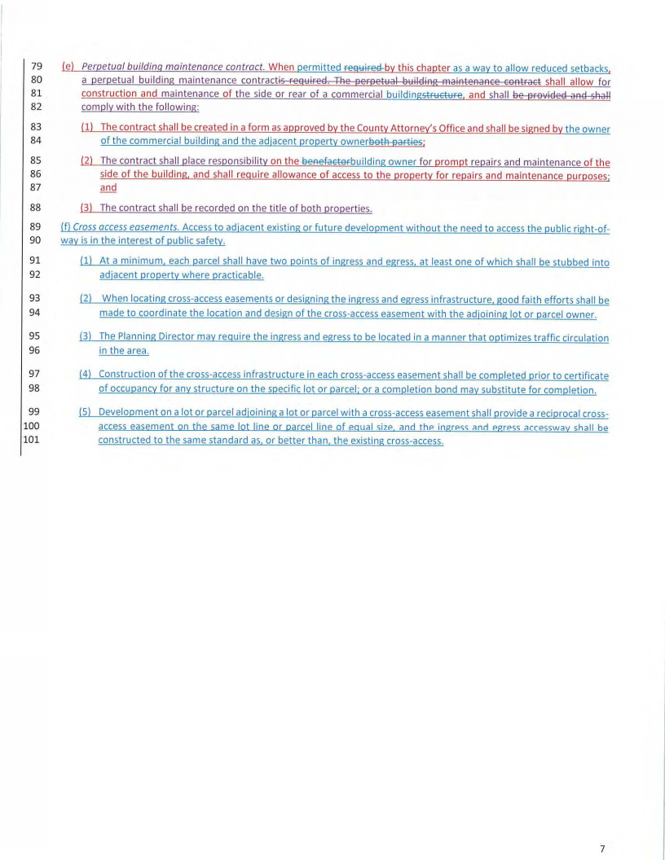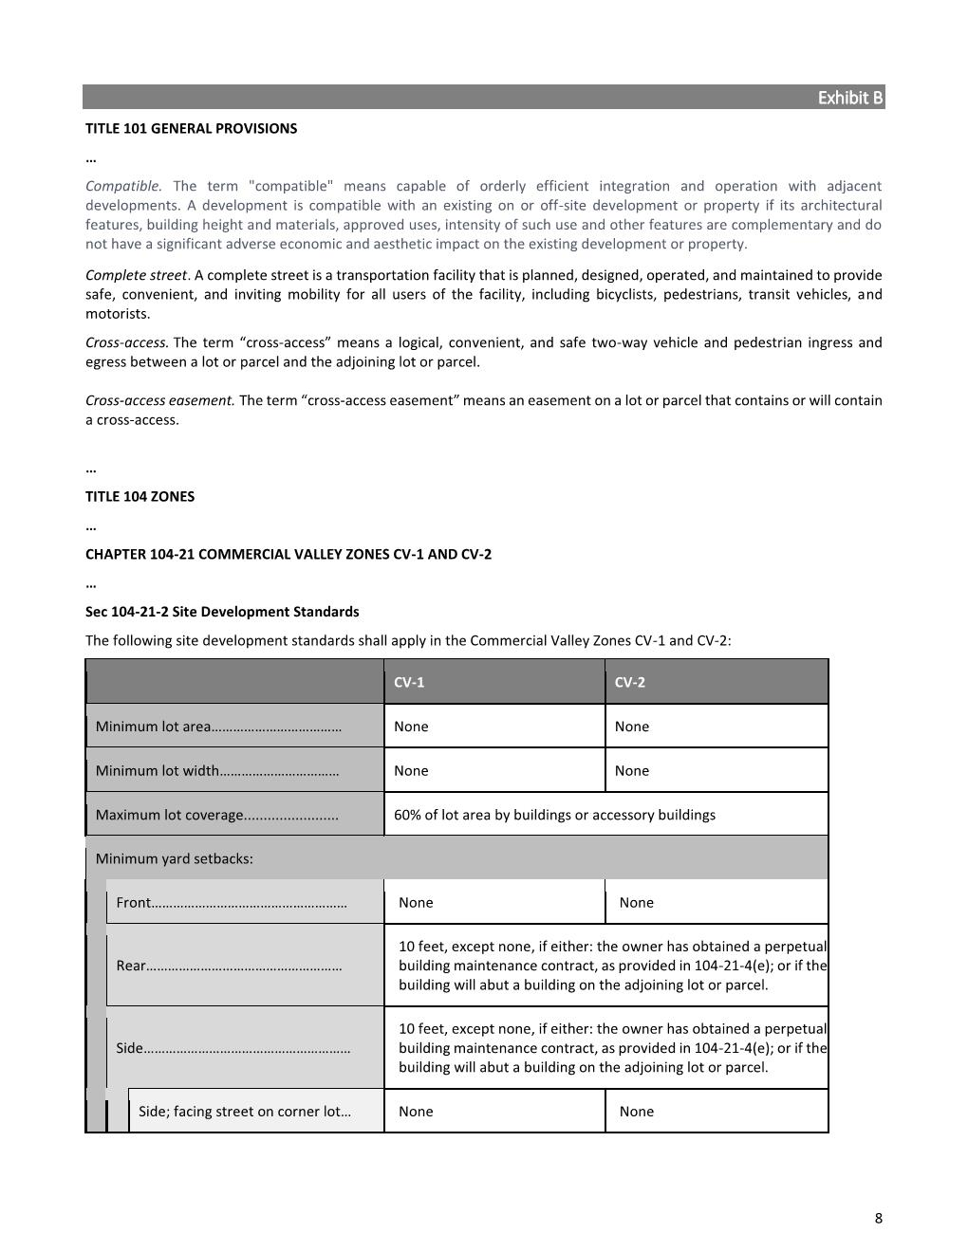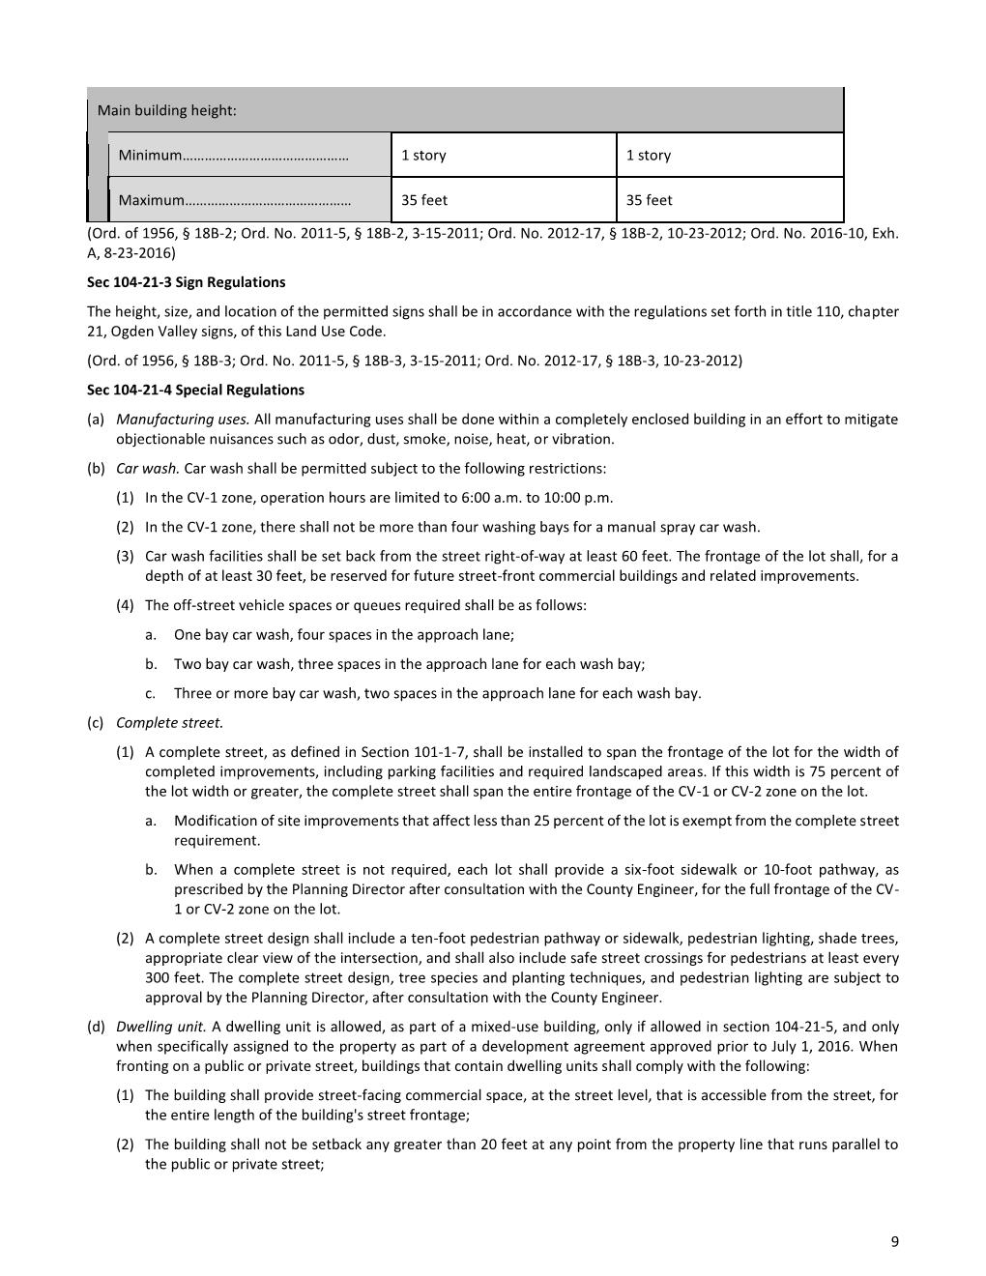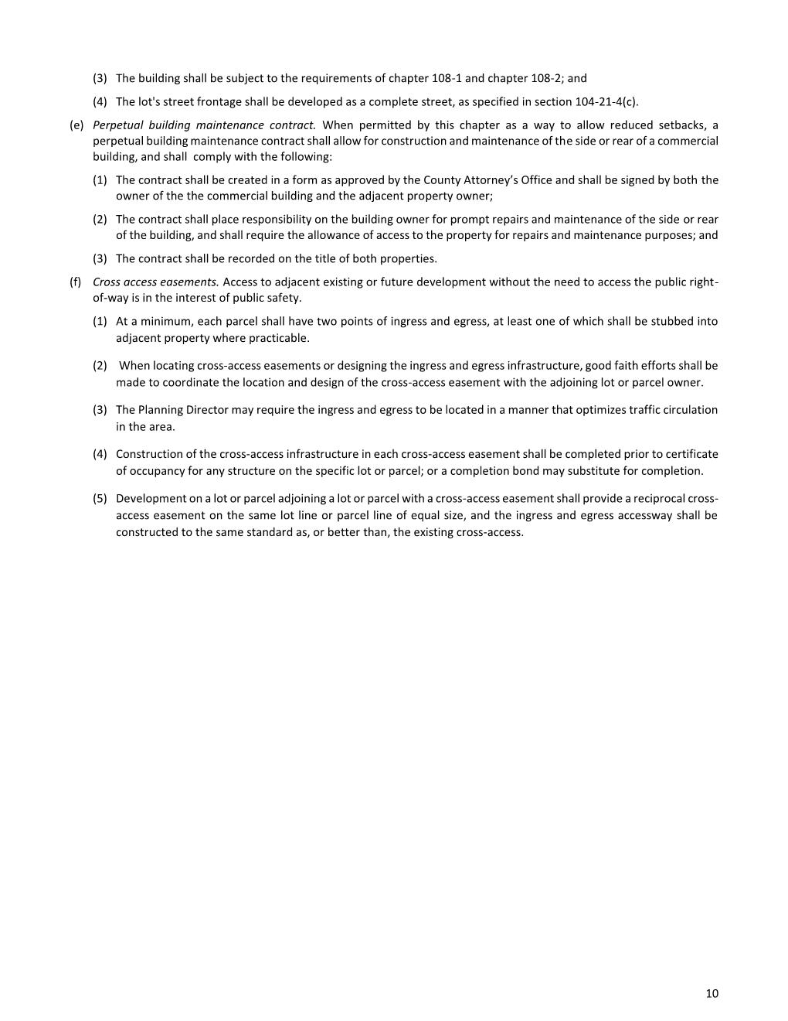

Planning Commission Staff Report: Attachment B

Planning Commission Staff Report: Attachment B

Planning Commission Staff Report: Attachment B

Planning Commission Staff Report: Attachment B

Planning Commission Staff Report: Attachment B

Planning Commission Staff Report: Attachment B

Planning Commission Staff Report: Attachment B

Planning Commission Staff Report: Attachment B

Planning Commission Staff Report: Attachment B

Planning Commission Staff Report: Attachment B

Planning Commission Staff Report: Attachment B

Planning Commission Staff Report: Attachment B

Planning Commission Staff Report: Attachment B

Minutes: Attachment C

Attachment C: Ogden Valley Planning Commission Minutes (04/28/2020)

1. **ZTA 2020-02: Public hearing to consider and take action on a proposal to amend the site development standards, remove unnecessary text, and add a Perpetual Building Maintenance Contract provision to the CV-1, CV-2 zone code. *Presenter Felix Lleverino***

Mr. Lleverino presented the item. He walked the Planning Commissioners through the staff report and highlighted the suggested amendments.

Commissioner Burton had a question about the cross access easement and if it was going to be required in all circumstances. Commissioner Burton also asked for the definition of a cross access easement.

Commissioner Francis made a motion to recommend approval to the County Commission ZTA 2020-02 subject to all staff recommendations and comments as noted in the staff report. Commissioner Wood Seconded the motion. Chair Lewis, Hogge, Howell, Francis, Burton, Wood and Waldrip all in favor voted aye. (motion carried)